Supplementary Table 1 Antibody details and dilution ratios
Antibody name | Manufacturer | Catalog number | Dilution ratios’ | Applications
β-actin | Proteintech | 60008-1-Ig | 1:5000 | Western Blot
Runx2 | Proteintech | 20700-1-AP | 1:800 | Western Blot
COL2A1 | Proteintech | 86139-2-RR | 1:2000 | Western Blot
COL2A1 | Proteintech | 28459-1-AP | 1:200 | IF Cell
COL2A1 | Proteintech | 86139-2-RR | 1:200 | IF Tissue
MMP13 | Proteintech | 18165-1-AP | 1:2000 | Western Blot
MMP13 | Proteintech | 18165-1-AP | 1:200 | IF Cell
MMP13 | Proteintech | 18165-1-AP | 1:200 | IF Tissue
COLX | Proteintech | 26984-1-AP | 1:800 | Western Blot
Runx2 | Proteintech | 20700-1-AP | 1:200 | Western Blot

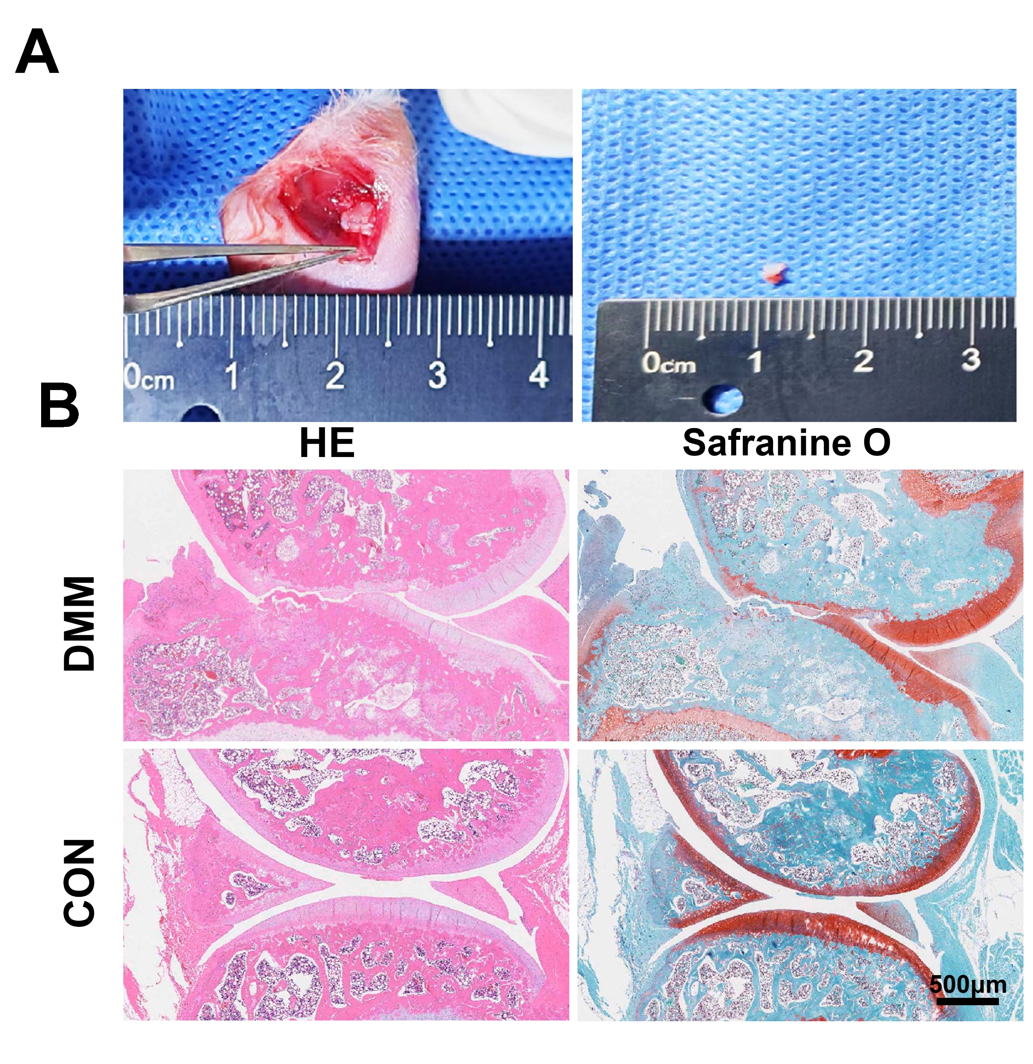
Supplementary Fig. S1. Creation and validation of the destabilization of medial meniscus (DMM) rat model of osteoarthritis. (A) Macroscopic view of the DMM surgical procedure in rats and the resected tissue. (B) Representative coronal histological sections of rats’ knee joints for the unoperated control (CON) and operated (DMM) groups at 4 weeks post-surgery.
Supplementary Fig. S2. Surgical procedure for in situ implantation of the HAMA-ART hydrogel in rat subchondral bone. (A) Injection of 30 μL of the HAMA-ART precursor solution into a prefabricated 3 mm subchondral bone drill hole in the exposed medial femoral condyle. (B) In situ photo-crosslinking and gelation of the HAMA-ART hydrogel induced by 365 nm UV irradiation.
Supplementary Fig. S3. Rheological and compressive mechanical characterization of HAMA and HAMA-ART hydrogels. (A, B) Representative time-sweep rheological curves showing the storage modulus (G′) and loss modulus (G″) of HAMA and HAMA-ART hydrogels after photo-crosslinking. (C) Quantitative analysis of the storage modulus and loss modulus of HAMA and HAMA-ART hydrogels. (D) Representative compressive stress–strain curves of HAMA and HAMA-ART hydrogels. (E, F) Quantitative analysis of compressive strength and compressive modulus. ns, not significant; *P < 0.05; **P < 0.01.

Supplementary Fig. S4. In vivo immunofluorescence analysis of Runx2 expression in subchondral bone after HAMA-ART treatment. (A) Representative immunofluorescence images of Runx2 expression in subchondral bone sections from the Sham, Saline, HAMA, and HAMA-ART groups. Nuclei were stained with DAPI, and Runx2 was stained in red. Scale bar: 100 μm. (B) Quantitative analysis of relative Runx2 fluorescence intensity in the subchondral bone region. Data are presented as mean ± SD. ns, not significant; **P < 0.01; ***P < 0.001.

