Supplementary Information

Development of a Soy Protein-Based Composite Hydrogel as a Platform for Three-dimensional Cell Culture of Human Salivary Glands

Table 1. Purchase information on reagents and instruments used for experiments.
Reagents | Catalogue Number | Manufacturer | Country of Origin
Soy Protein Isolate (SPI) | NISTRM8186 | Sigma-Aldrich | United States
Protanal ® LF 10/60 Sodium Alginate | 2210511 | FMC BioPolymer | Norway
Gelatin | G9391-500G | Sigma-Aldrich | United States
Calcium Chloride | 22317.297 | VWR International | Belgium
Epi Max | 002-010 | Wisent Inc. | Canada
Trypsin-EDTA Solution | 25300054 | Gibco™ | United States
Matrigel® GFR Basement Membrane Matrix | 356231 | Corning Incorporated | United States
WST-8 Cell counting kit | AB228554 | Abcam | United Kingdom
Live/Dead ®Viability/Cytotoxicity Kit | L3224 | Invitrogen™ | United States
Hoechst | 33342 | Tocris Bioscience | United Kingdom
AQP-5 | PA5-99403 | ThermoFisher Scientific | United States
E-Cad | ab1416 | Abcam | United Kingdom
ZO-1 | ab221547 | Abcam | United Kingdom
α-SMA | ab7817 | Abcam | United Kingdom
CK-5 | ab52635 | Abcam | United Kingdom
CK-7 | ab181598 | Abcam | United Kingdom
CK-14 | ab7800 | Abcam | United Kingdom
α-Amylase | ab201450 | Abcam | United Kingdom
αSMA | ab7817 | Abcam | United Kingdom
CD117 (c-kit) | ab187371 | Abcam | United Kingdom
F-actin - Phalloidin-iFluor™ 488 Conjugate | 23115 | AAT Bioquest, Inc. | United States
Alexa Fluor® 488 AffiniPure™ Donkey Anti-Goat IgG (H+L) | 705-545-003 | Jackson ImmunoResearch Laboratories, Inc. | United States
Goat anti-Rabbit IgG (H+L) Cross-Adsorbed Alexa Fluor 594 | A-11012 | ThermoFisher Scientific | United States
Goat anti-Mouse IgG (H+L) Cross-Adsorbed Alexa Fluor 594 | A-11005 | ThermoFisher Scientific | United States
Fluo-4 AM Calcium Imaging Kit | F10489 | ThermoFisher Scientific | United States
Bovine Serum Albumin (BSA) | A7906 | Sigma-Aldrich | United States
αMEM | 12571063 | ThermoFisher Scientific | United States
HEPES-buffered saline | J62623.AK | ThermoFisher Scientific | United States
Carbachol (Carbamoylcholine chloride) | C4382 | Sigma-Aldrich | United States
Isoprenaline (Isoprenaline hydrochloride) | I5627 | Sigma-Aldrich | United States
ATP (Adenosine 5′-triphosphate disodium salt hydrate) | A2383 | Sigma-Aldrich | United States
DPBS (no calcium, no magnesium) | 14190144 | ThermoFisher Scientific | United States
Antibiotic-Antimycotic (100X) | 15240062 | Gibco™ | United States
Fetal Bovine Serum (FBS) | 10082147 | Gibco™ | United States
DAPI | D1306 | Invitrogen™ | United States
FT-IR Spectrometer | Tensor 27 | Bruker Optik GmbH | United States
Leica EM ACE600 High-Vacuum Sputter Coater | EM ACE 600 | Leica Microsystems Inc. | Germany
FlexSEM 1000II Scanning Electron Microscope (SEM) | SU1000 | Hitachi High-Tech Corporation | Japan
MicroSquisher | N/A | CellScale Biomaterials Testing | Canada
Confocal Laser Scanning Microscope | LSM 980 | Carl Zeiss Microscopy GmbH | Germany

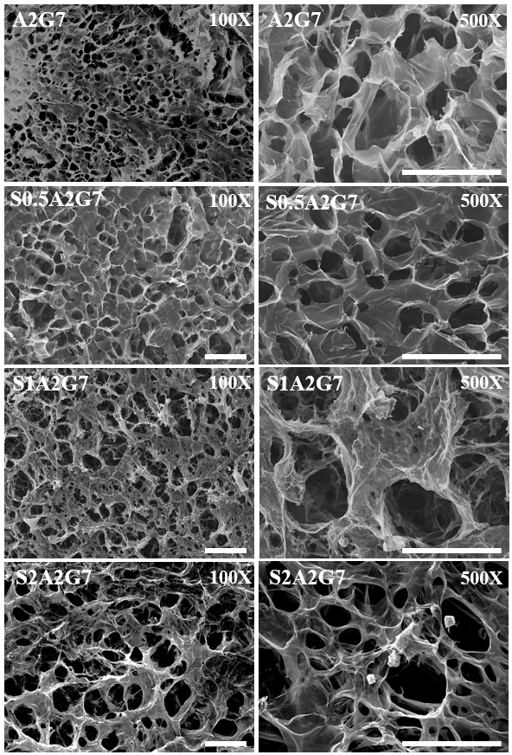

Figure 1. Cross-sectional SEM images of different concentrations of soy-based hydrogel groups at the magnification of 100x (left column) and 500x (right column) on Day 1. Scale bar:100µm.

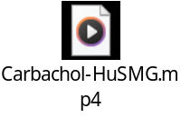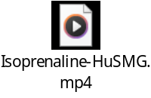
C)
B)
D)
A)
Figure 2: Videos of the functional assessment of HuSMG spheroids encapsulated in a soy-based hydrogel (S2A2G7) and stimulated with A) Ca²⁺/Mg²- Free DPBS (negative control), B) ATP (100 µM), C) Carbachol (100 µM), and D) Isoprenaline (100 µM). Changes in calcium influx were observed over 5 minutes in the calcium assay. Magnification: 20×; Scale bar: 100 µm.
D)
C)
B)
A)
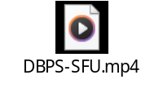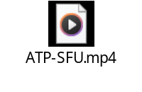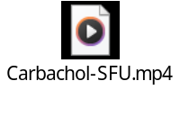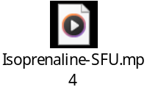
Figure 3: Videos of the functional assessment of human salivary gland organoids. The organoids were grown from salivary functional units (SFUs) cultured in a soy-based hydrogel (S2A2G7) for 28 days, then stimulated with A) Ca²⁺/Mg²- Free DPBS (negative control), B) ATP (100 µM), C) Carbachol (100 µM), and D) Isoprenaline (100 µM). Changes in calcium influx were observed over 5 minutes in the calcium assay. Magnification: 20×; Scale bar: 100 µm.
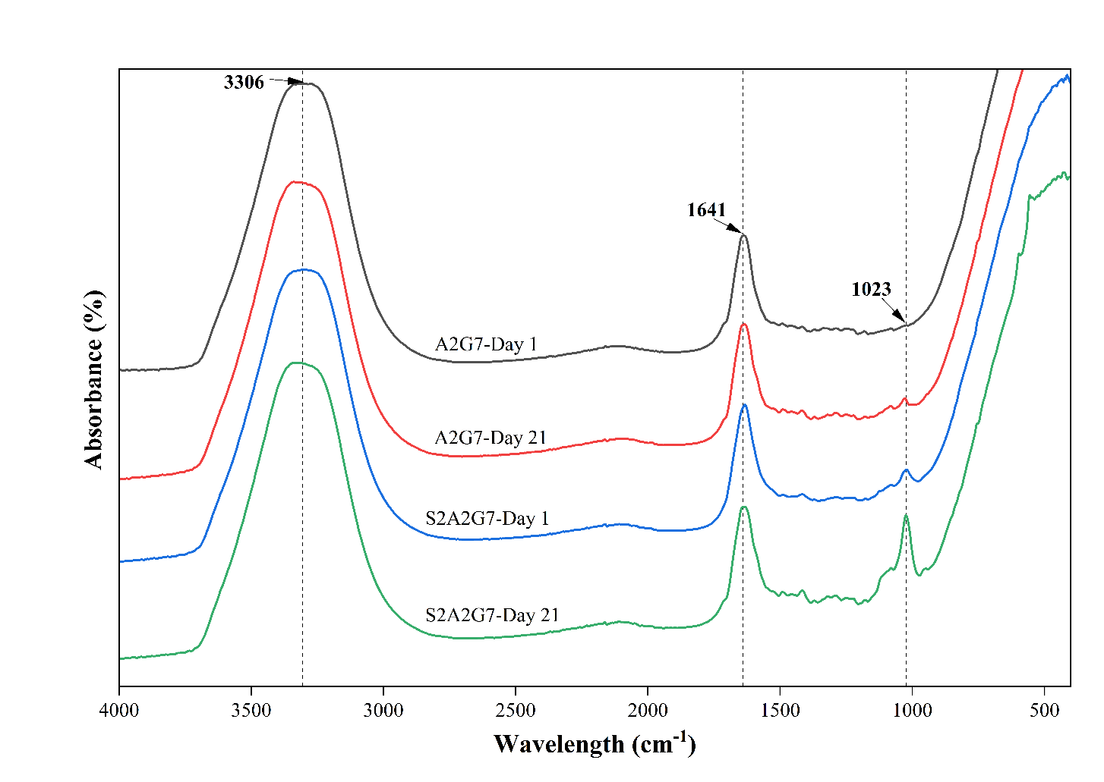

Figure 4. FTIR spectra of the incubated media of soy-based hydrogel (S2A2G7) and the control group (A2G7) on Day 1 and Day 21.

