Original Article
Diffusion-Mediated Post-Gelation Microstructural Tuning of GelMA Hydrogels for Cell-Permissive Tissue Engineering
Karthika Muthuramalingam¹ and Hyun Jong Lee^{1,*}
¹ School of Chemical, Biological and Battery Engineering, Gachon University, 13120 Seongnam-si, Gyeonggi-do, Republic of Korea
* Correspondence: hjlee2@gachon.ac.kr (H.J.L.)
ORCID
Karthika Muthuramalingam: https://orcid.org/0009-0008-5005-7407
Hyun Jong Lee: https://orcid.org/0000-0002-6443-0902

Supplementary
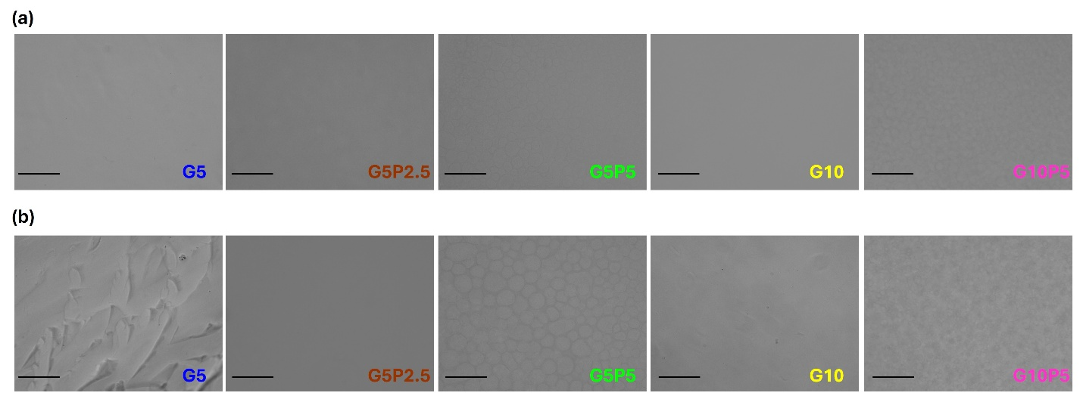
Supplementary Fig. 1: Brightfield microscopic images of the hydrogel microstructure (a) immediately after fabrication and (b) after immersion in DMEM for 48 h. Scale bar = 150 μm; magnification = 20×.

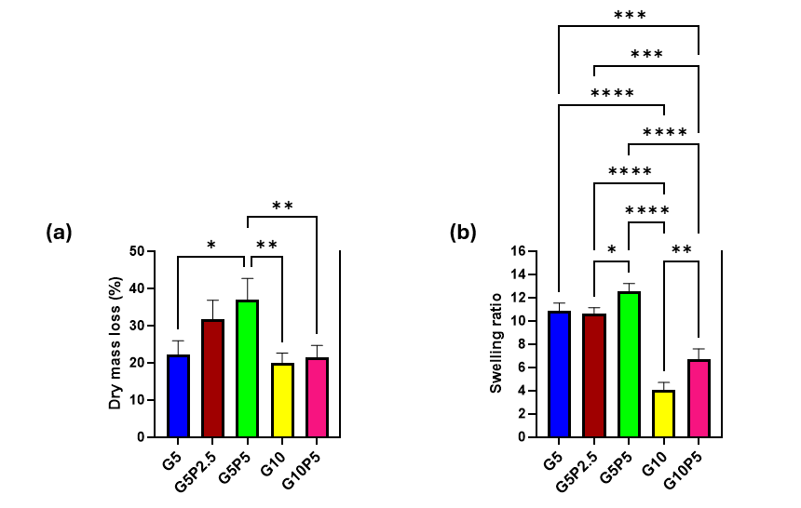
Supplementary Fig. 2: (a) Dry mass loss of GelMA/PF127 hydrogels following immersion in PBS for 48 h, calculated from the difference between the initial freeze-dried mass prior to swelling and the final freeze-dried mass obtained after re-lyophilization. (b) Equilibrium swelling ratio of hydrogels determined using the swollen mass at equilibrium (24 h) normalized to the final dry mass after re-lyophilization. Hydrogel mass was recorded at 1, 3, 5, 24, and 48 h during PBS immersion to monitor swelling behavior and determine equilibrium swelling. Data are presented as mean ± standard deviation (n = 3). Statistical significance is denoted as *p < 0.05, **p < 0.01, ***p < 0.001, and ****p < 0.0001. This figure was generated using GraphPad Prism software (GraphPad Software, San Diego, CA, USA).
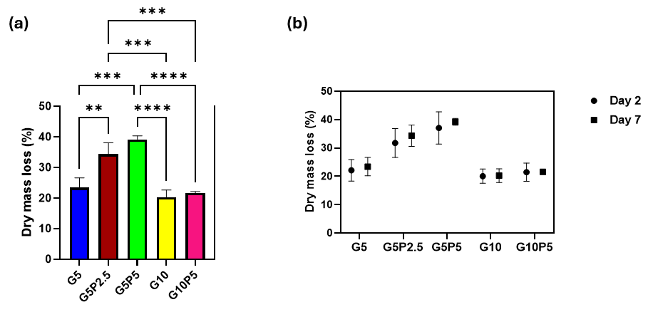
Supplementary Fig. 3: Long-term dry mass loss of GelMA/PF127 hydrogels following immersion in PBS at 37 °C. (a) Dry mass loss after 7 days of immersion, determined from the difference between the initial freeze-dried mass prior to immersion and the final freeze-dried mass obtained after re-lyophilization. (b) Comparison of dry mass loss after 2 days (48 h; data reproduced from Supplementary Figure S2a) and 7 days of PBS immersion, illustrating the stability of the hydrogel formulations following the initial equilibration period. Data are presented as mean ± standard deviation (n = 3). Statistical significance is denoted as *p < 0.05, **p < 0.01, ***p < 0.001, and ****p < 0.0001. This figure was generated using GraphPad Prism software (GraphPad Software, San Diego, CA, USA).

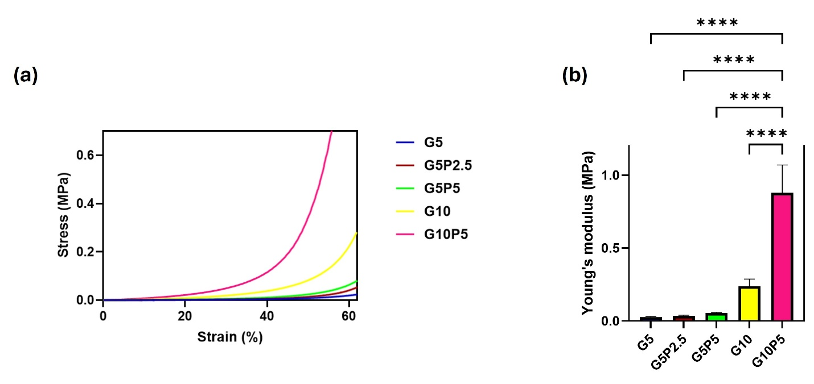
Supplementary Fig. 4: Large-deformation compressive mechanical characterization of freshly prepared GelMA/PF127 hydrogels. (a) Representative stress–strain curves obtained by unconfined compression testing. (b) Compressive Young's modulus determined from the linear region of the stress–strain curves. Data are presented as mean ± standard deviation (n = 3). Statistical significance is denoted as ****p < 0.0001. This figure was generated using GraphPad Prism software (GraphPad Software, San Diego, CA, USA).
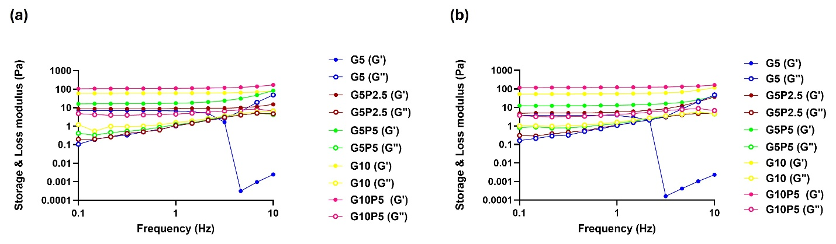
Supplementary Fig. 5: Frequency sweep rheological characterization of GelMA/PF127 hydrogels after 10 days of incubation at 37°C. (a) Storage modulus (G') and loss modulus (G'') of freshly prepared acellular hydrogels after immersion in PBS for 10 days. (b) Storage modulus (G') and loss modulus (G'') of C2C12-laden hydrogels after culture in DMEM for 10 days. This figure was generated using GraphPad Prism software (GraphPad Software, San Diego, CA, USA).
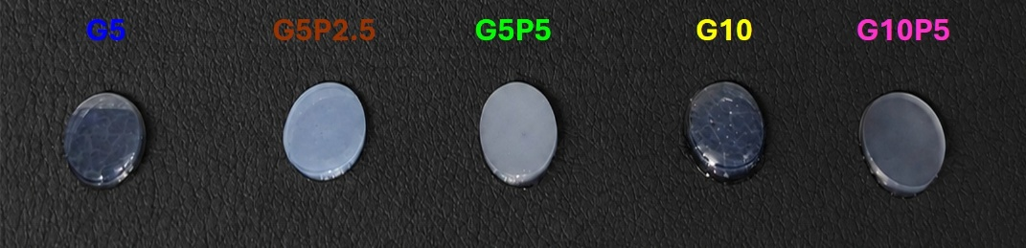
Supplementary Fig. 6: Optical images illustrating the macroscopic structural stability of hydrogels during immersion in PBS for 10 days.
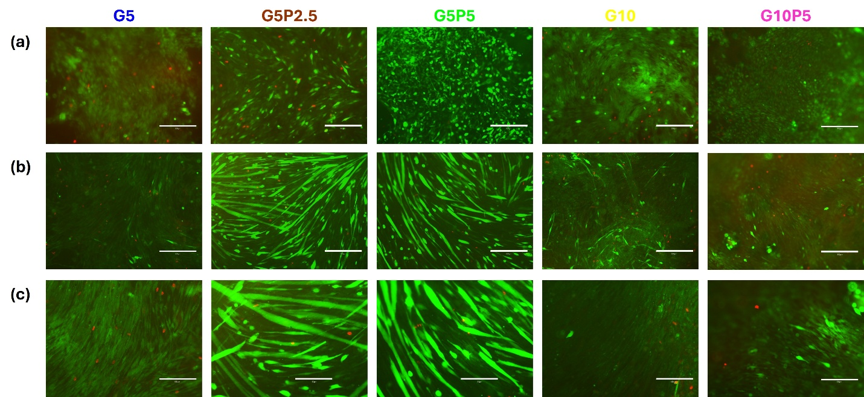
Supplementary Fig. 7: Representative Live/Dead fluorescence images of C2C12-laden GelMA/PF127 hydrogels cultured for (a) 7 days (10×), (b) 10 days (10×), and (c) 10 days (20×). Live cells are shown in green and dead cells in red. Scale bars: 300 μm for (a) and (b), and 150 μm for (c).

