Original Article
Study on the Repair Effects and Mechanisms of Acanthopanax Senticosus Glycoprotein in Ultraviolet-Induced Skin Photoaging
Ye Jin^{1,2,†}, Dongmei Fan^{1,†}, Zhongyi Yang³, Xushuang Jia¹, Yuanyuan Jin¹, Jing He¹, Jianming Xing⁴, Hailiang Wang^{3,}* and Da Liu^{1,5,*}
¹School of Pharmacy,Changchun University of Chinese Medicine; Changchun 130117,China;
²Northeast Asian Institute of Traditional Chinese Medicine, Changchun University of Chinese Medicine,Changchun 130117, China
³Department of Dermatology, The Affiliated Hospital to Changchun University of Chinese Medicine; Changchun 130021, China;
⁴Australian Institute for Bioengineering and Nanotechnology, The University of Queensland, Brisbane, QLD 4072, Australian
⁵Public Experimental Center, Changchun University of Chinese Medicine, Changchun 130117, China
* Correspondence: whldoctor@sina.com(HLW); liuda@ccucm.edu.cn (DL)
† These authors contributed equally to this work.

Table S1
Synthesis steps of polypeptides 1-5
Peptide name | Synthesis method
Peptide 1 - GVGMNPVDHPHGGGEGR (GVG) | The n-equivalent resin was solubilized in DCM, removed and synthesized from C-terminal to N-terminal.Amino acids such as Fmoc-Arg-OH, Fmoc-Gly-OH, and Fmoc-Glu-OH were added in sequence, and the reaction was promoted using HBTU and DIEA.Each step of the reaction was followed by capping with pyridine and acetic anhydride to remove the Fmoc protecting group.After synthesis, the resin was filtered, the crude product was precipitated by the addition of ether, centrifuged, washed, purified and lyophilized.
Peptide 2 - EAYPGDVFYLHSR (EAY) | In the same step, the resin was solubilized in DCM and synthesized from C- to N-terminal.  Fmoc-Arg-OH, Fmoc-Gly-OH, Fmoc-Glu-OH were added and the reaction was promoted using HBTU and DIEA.  The Fmoc protecting group was removed by capping with pyridine and acetic anhydride.After completion of synthesis treatments were the same as for peptide 1.
Peptide 3 - VFDKDQNGFISAAELR (VFD) | Following similar steps, the resin was solubilized in DCM and synthesized from C- to N-terminal.Fmoc-Arg-OH, Fmoc-Leu-OH, and Fmoc-Glu-OH were added, and HBTU and DIEA were used.  Treatment and purification were the same as for peptide 1.
Peptide 4 - AVVVHGDPDDLGR (AVV) | Perform similar resin solubilization and synthesis processes.Fmoc-Arg-OH, Fmoc-Gly-OH, Fmoc-Leu-OH, HBTU, DIEA were used.The synthesis, purification, and lyophilization steps were the same as described previously.
Peptide 5 - EADVDGDGQINYEEFVK (EAD) | The resin was solubilized in DCM and synthesized from C-terminal to N-terminal.  Fmoc-Arg-OH, Fmoc-Val-OH, Fmoc-Glu-OH were added according to the sequence, using HBTU and DIEA.  The treatment was the same as the previous peptides and final lyophilization.

Table S2
Results of protein identification for the purpose of As-Gp
Protein number | Protein Name | Gene Name | Protein molecular weight（kDa） | protein score | Sequence coverage（%） | Number of specific peptides | Number of peptides | Number of secondary spectra | abundances
A0A7H1CMG8 | 50Sribosomal protein L2, chloroplastic | rpl2 | 30.0 | 77 | 6 | 1 | 1 | 2 | 61842798
A0A1B1MSL3 | ATPsynthase subunitalpha,chloroplastic | atpA | 55.5 | 57 | 3 | 1 | 1 | 1 | 13899101
I0E1Y3 | Calmodulin | Cam | 16.8 | 52 | 22 | 2 | 2 | 2 | 17316783.5
I0E1Y5 | Superoxide dismutase[Cu-Zn] | SOD | 15.2 | 41 | 9 | 1 | 1 | 1 | 12692920

Table S3
Sequence characterization of peptide fragments of glycoproteins of As-Gp.
peptide sequence | Modification Type | Number of secondary maps | Protein number | Number of missed cuts | Molecular weight | abundances | electric charge | mass error（ppm） | quality error
GVGMNPVDHPHGGGEGR | 1xOxidation [M4] | 2 | A0A7H1CMG8 | 0 | 1688.76 | 61800000 | 2 | -0.21 | 8.77
EAYPGDVFYLHSR | - | 1 | A0A1B1MSL3; A0A1B1MSG5 | 0 | 1553.74 | 13899101 | 2 | 0.01 | 17.01
VFDKDQNGFISAAELR | - | 1 | I0E1Y3 | 1 | 1809.91 | 11758749 | 3 | -0.33 | 17.01
AVVVHGDPDDLGR | - | 1 | I0E1Y5 | 0 | 1349.68 | 12692920 | 2 | 5.09 | 11.70
EADVDGDGQINYEEFVK | - | 1 | I0E1Y3 | 0 | 1927.86 | 5558034.5 | 2 | 0.34 | 18.34

Fig .S1 The chromatogram of the monosaccharide standard.
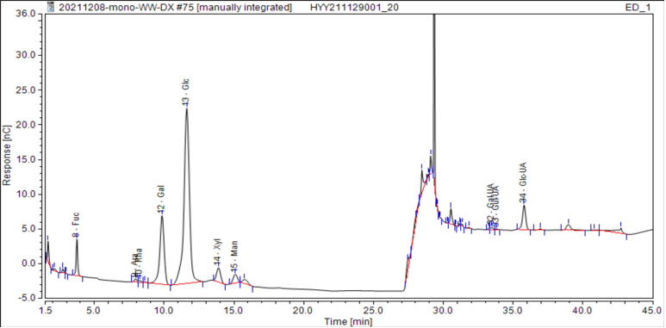
Fig .S2 The chromatogram of the Acanthopanax senticosus glycoprotein sample.
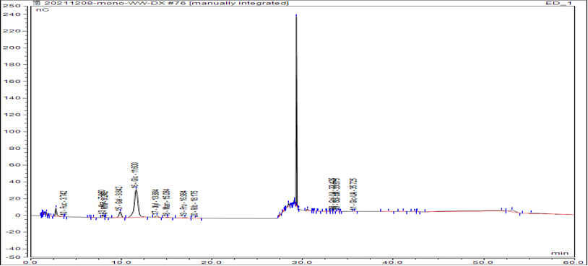

Fig .S3 Schematic diagram of sample preparation.
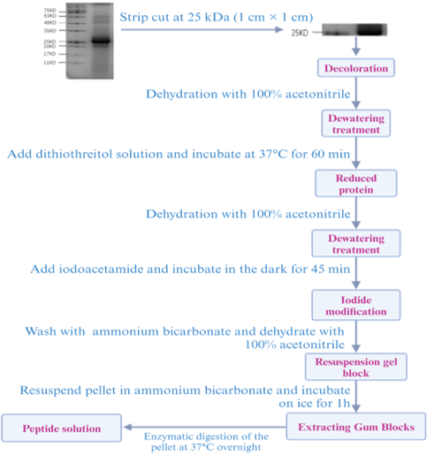
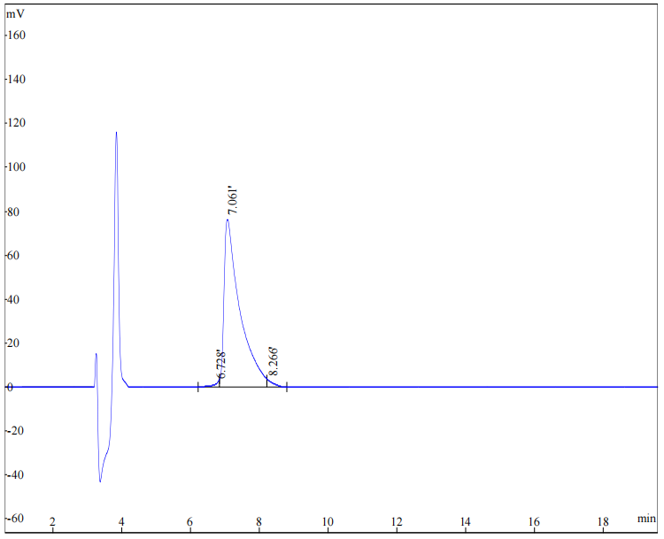
Fig .S4 Synthetic peptide 1 HPLC spectrum

Fig .S5 Synthetic peptide 2 HPLC spectrum
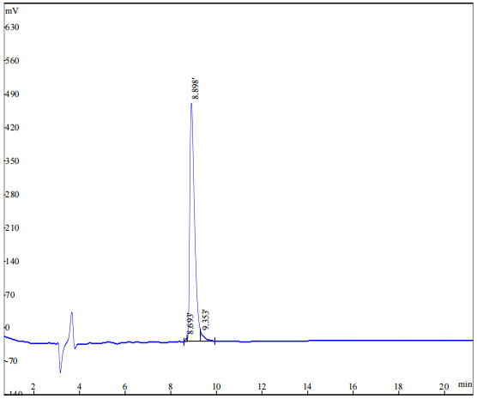

Fig .S6 Synthetic peptide 3 HPLC spectrum
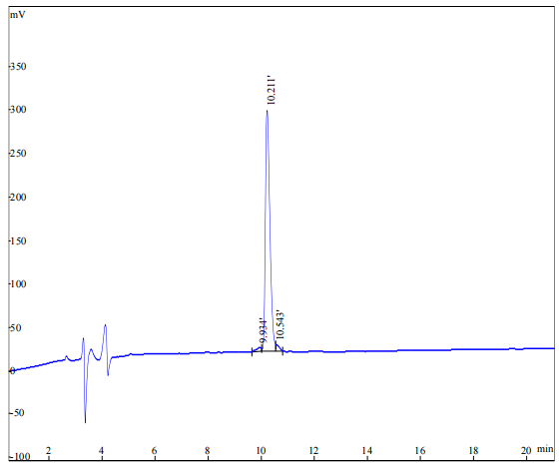

Fig .S7 Synthetic peptide 4 HPLC spectrum
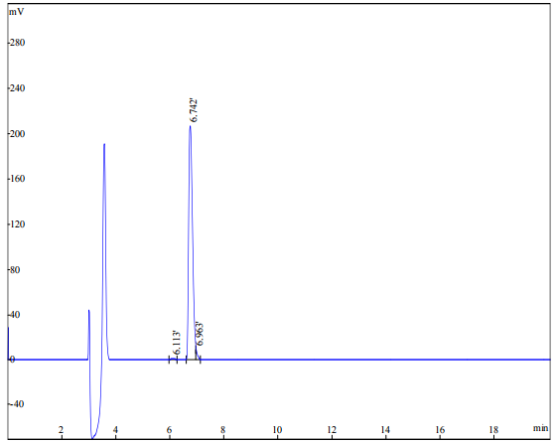

Fig .S8 Synthetic peptide 5 HPLC spectrum
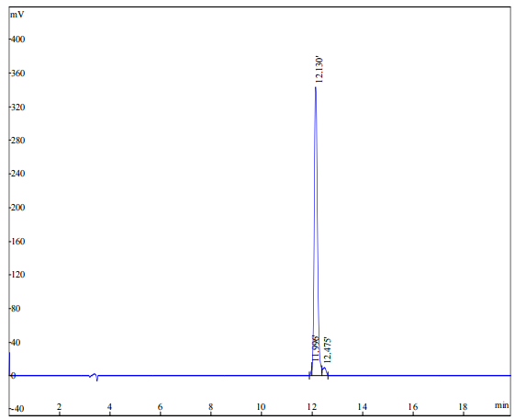

Fig .S9 Mass spectrometry (MS) spectrum of synthetic peptide 1
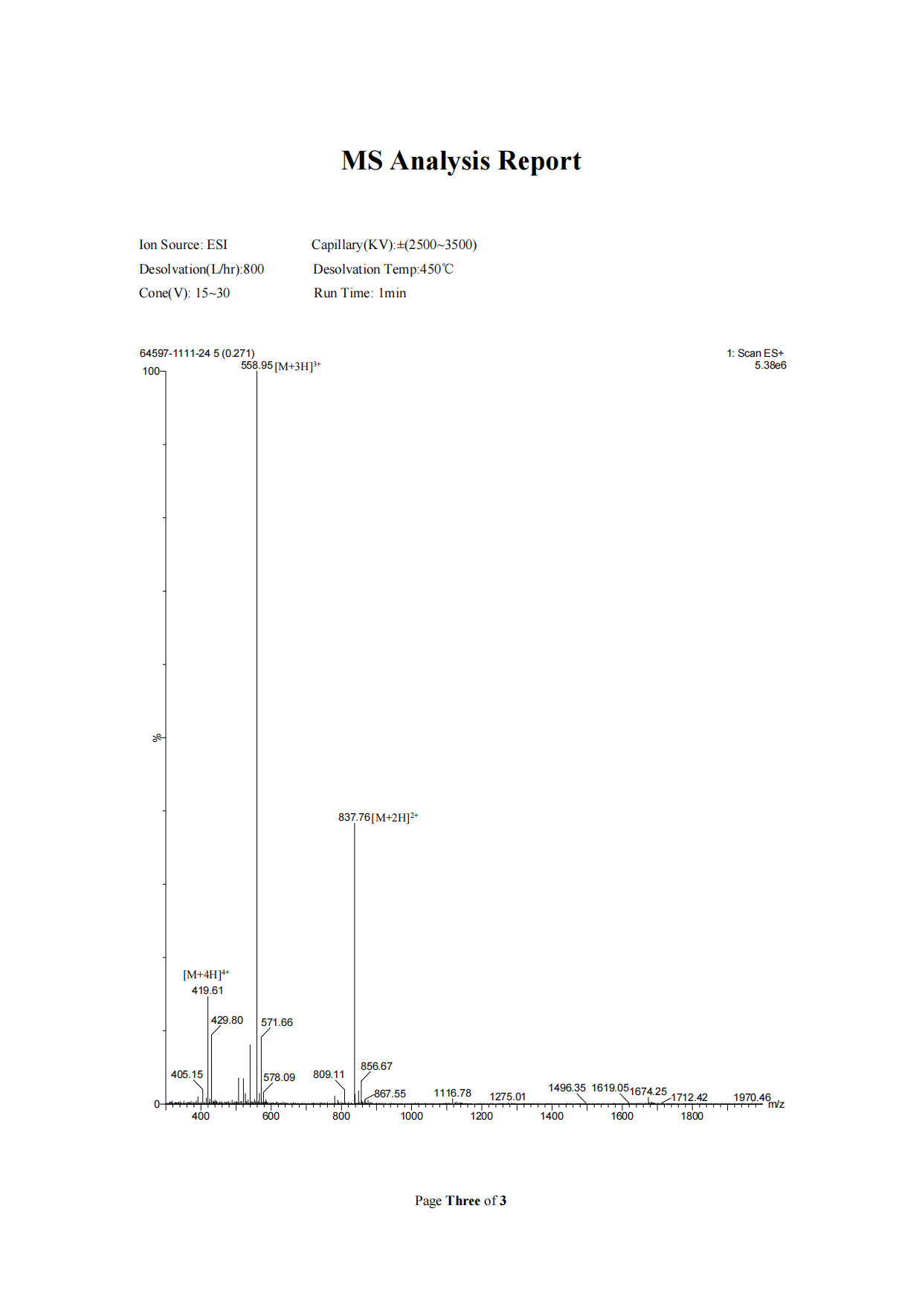

Fig .S10 Mass spectrometry (MS) spectrum of synthetic peptide 2
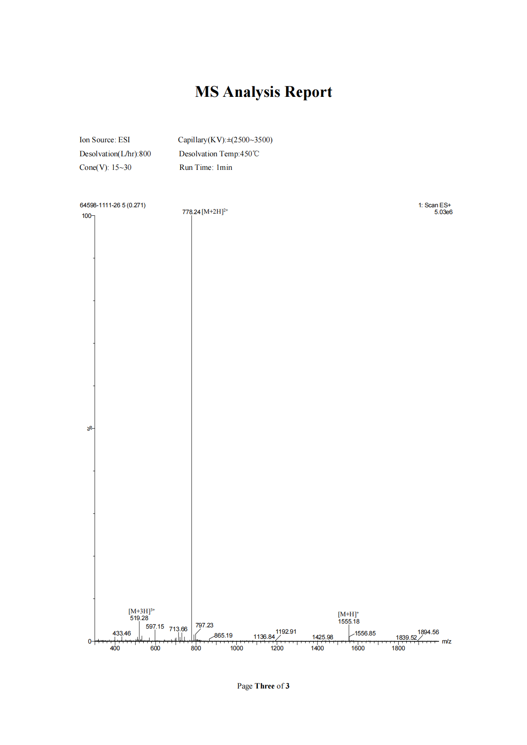
Fig .S11 Mass spectrometry (MS) spectrum of synthetic peptide 3
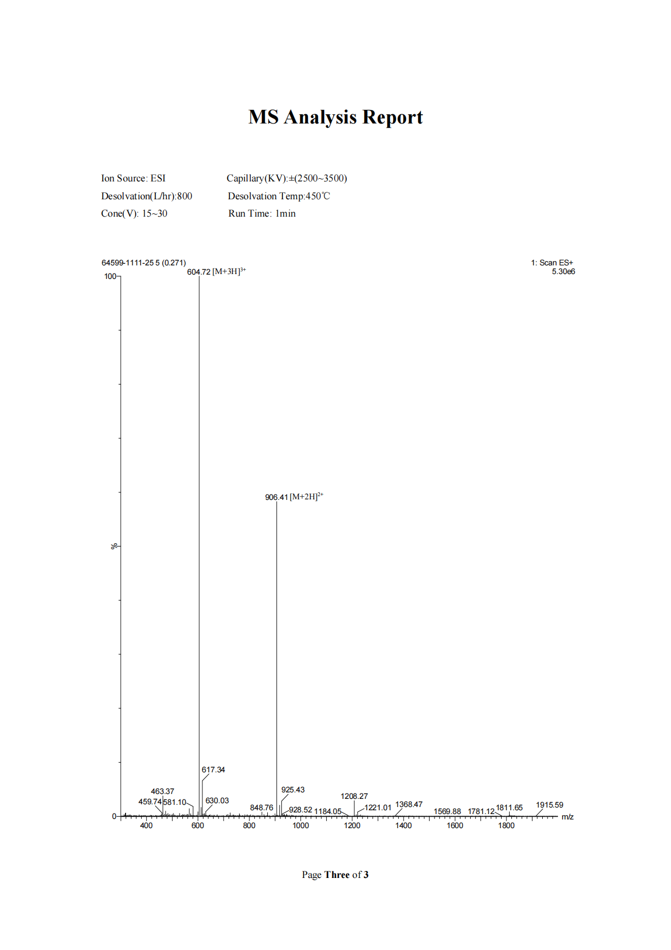

Fig .S12 Mass spectrometry (MS) spectrum of synthetic peptide 4
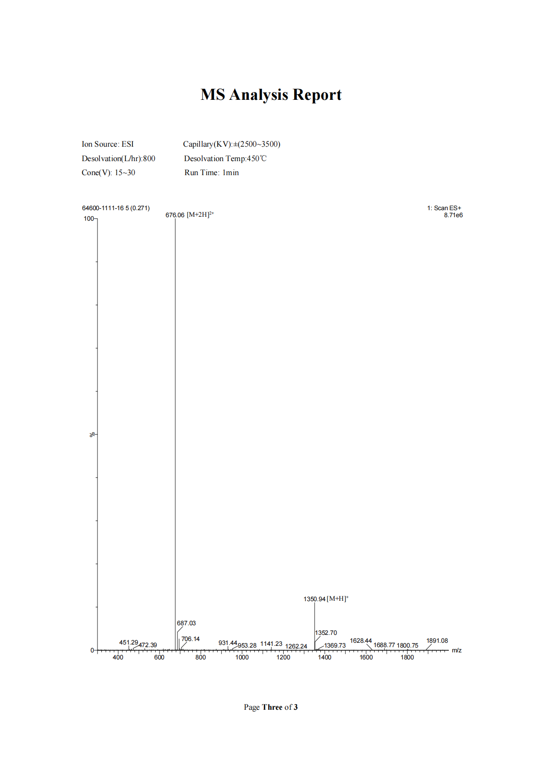
Fig .S13 Mass spectrometry (MS) spectrum of synthetic peptide 5
