Supplementary Material

A pH-Responsive Nanocarrier Improves Astragaloside IV Bioavailability and Reverses Cardiac Dysfunction in Heart Failure
Lingfen Lu¹, Xiaojun Ji¹, Shanjiang Chen¹, Lianglei Hou¹, Yiwei Huang¹, Ze Zhuge¹, Zhongping Shi^{1,}*
¹Department of Cardiology, Wenzhou Central Hospital, 325000 Wenzhou, Zhejiang, China
* Correspondence: E-mail address: szphello1981@163.com (Zhongping Shi).

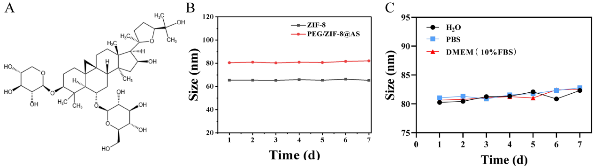
Figure S1. (A) The structural formula of AS. (B) Particle size measurements of ZIF-8 and PEG/ZIF-8@AS NPs dispersed in water over seven days. (C) Particle size measurements of PEG/ZIF-8@AS NPs dispersed in water, PBS, and high-glucose DMEM culture medium (containing 10% FBS) over seven days.
Figure S2. Quantification of H9c2 cells' surface area based on phalloidin-TRITC staining. #p < 0.05, vs. Ang-II + AS; $$p < 0.01, vs. Ang-II + ZIF-8; *p < 0.05, **p < 0.01, ***p < 0.001, vs. Ang-II.
Figure S3. Quantification of myocardial fibrosis area in H&E stained sections of heart tissue. ###p < 0.001, vs. TAC + AS; $$$p < 0.001, vs. TAC + ZIF-8; *p < 0.05, ***p < 0.001, vs. TAC.
Figure S4. Quantification of the expression of Bax, Bcl-2, and cleaved caspase3 protein in H9c2 cells. ###p < 0.001, vs. Ang-II + AS; $$$p < 0.001, vs. Ang-II + ZIF-8; **p < 0.01, ***p < 0.001, vs. Ang-II.

Figure S5. Quantification of the ratio of p-Akt/Akt, expression of VEGFR2, VEGF, and HIF-α protein in H9c2 cells. #p < 0.005, ##p < 0.01, vs. Ang-II + AS; $$$p < 0.001, vs. Ang-II + ZIF-8; **p < 0.01, ***p < 0.001, vs. Ang-II.

Table S1. Primers sequences for RT-qPCR
Gene | Primers sequences
β-MHC | F 5′-TGTGAAGGAGGACCAGGTGATG-3'
β-MHC | R 5'-ATAGGCGTTGTCAGAGATGGAGAA-3'
ANP | F 5′-GAGAGCGGACTAGGCTGCAA-3′
ANP | R 5′-TCAGTGGCAATGCGACCAA-3′
BNP | F 5′-GTCTCCAGAACAATCCACGATG -3'
BNP | R 5'-AAGGCGCTGTCTTGAGACCTAA-3'
GAPDH | F 5′-GACAACTTTGGCATCGTGGA-3′
GAPDH | R 5′-ATGCAGGGATGATGTTCTGG-3′

