Supplementary Information

Photo-crosslinked hydrogel for enhanced bone defect regeneration via sustained release OGP(10-14)

This file includes:
Tables S1 to S3
Figures S1 to S6

Supplementary Tables
Table S1. The RT-qPCR primer sequences for target genes
Gene | Forward | Reverse
Col1a1 | GCTCCTCTTAGGGGCCACT | ATTGGGGACCCTTAGGCCAT
Runx2 | GACTGTGGTTACCGTCATGGC | ACTTGGTTTTTCATAACAGCGGA
Sp7 | TCGTCTGACTGCCTGCCTAGTG | CTGCGTGGATGCCTGCCTTG
Gapdh | AAATGGTGAAGGTCGGTGTG | TGAAGGGGTCGTTGATGG
β-catenin | ATGGAGCCGGACAGAAAAGC | CTTGCCACTCAGGGAAGGA
c-myc | GCTCTCCATCCTATGTTGCG | TCCAAGTAACTCGGTCATCATC
CTSK | AGCAGAACGGAGGCATTGACTC | CCCTCTGCATTTAGCTGCCTTTG
MMP9 | TGCCCAGCGACCACAACTC | CGGACCCGAAGCGGACATT

Table S2. Antibodies for Immunohistochemistry - Paraffin
Name | Company | Dilution ratio
β-catenin | Santa Cruz | 1:100
Col1a1 | Bioworld | 1:100

Table S3. Mycoplasma test results

 | Mycoplasma free PBS | BMMs | Osteoblasts
B/A ratio  (ratio＜0.9, negative) | 0.197376449 | 0.099162011 | 0.071257485
B/A ratio  (ratio＜0.9, negative) | 0.213004484 | 0.179624665 | 0.077974277
B/A ratio  (ratio＜0.9, negative) | 0.187141948 | 0.168336673 | 0.086956522
Result Interpretation | Negative | Negative | Negative

Supplementary Figures

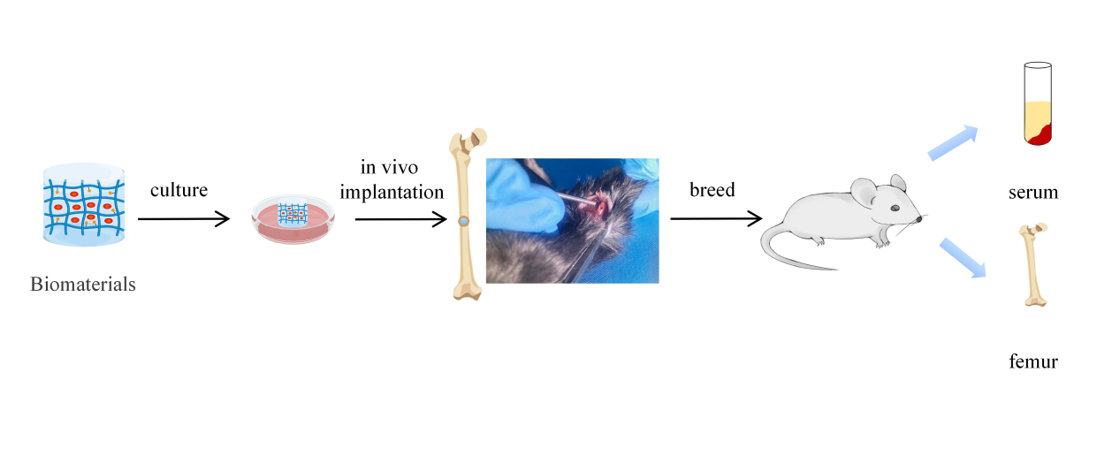
Figure S1. The schematic diagram of animal experiments.

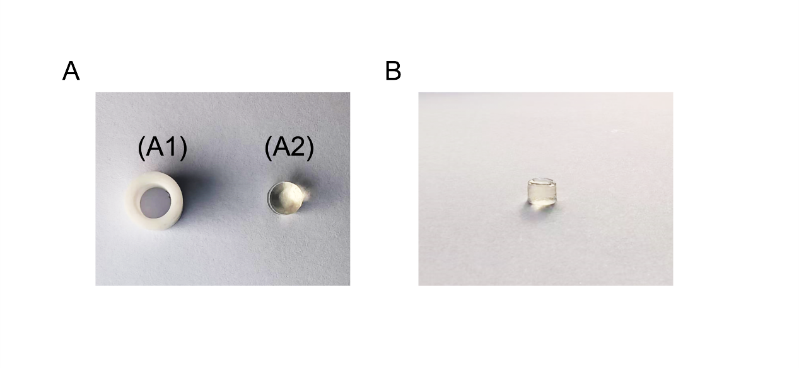
Figure S2. Photography images of primary osteoblasts seeded on the composite materials. (A1) The mold for synthesizing composite hydrogel. (A2) The photography image of AC-PEG-OGP(10-14) group. (B) The photography image of the AC-PEG-OGP(10-14) group implanted in osteoblasts.
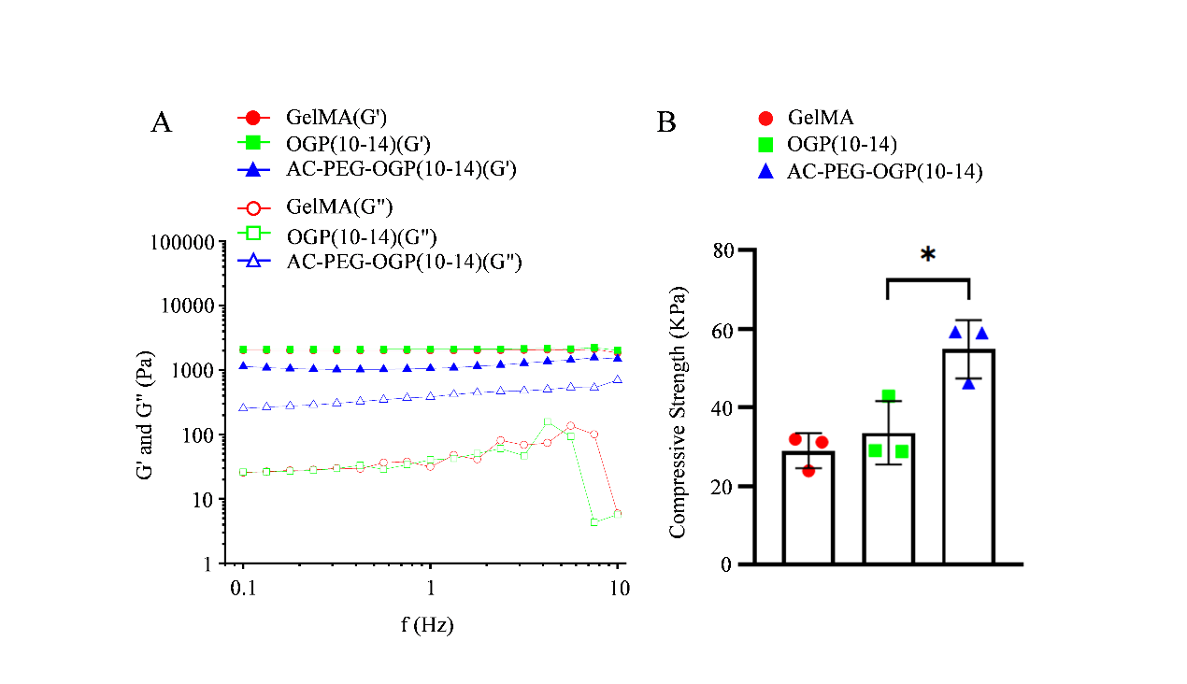
Figure S3. The mechanical property experiment. (A) The fluctuation of storage modulus (G') and loss modulus (G'') with frequency (Hz) allowed for the frequency sweep. (B) Statistical analysis of the compressive strength.

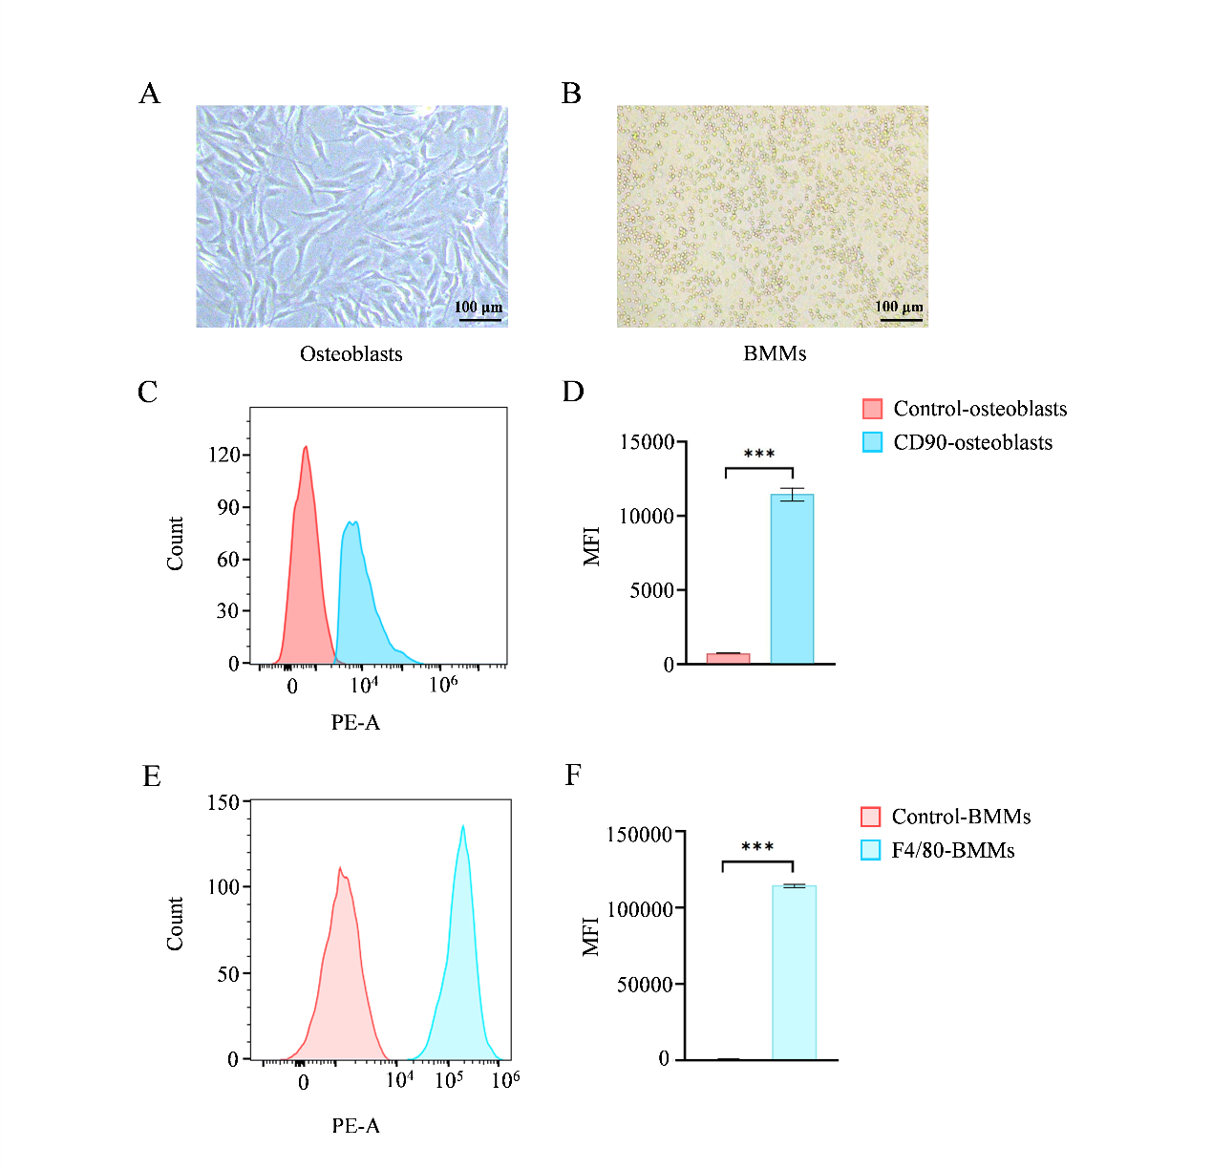
Figure S4. Isolation of primary cells and flow cytometry analysis. (A) Morphology of osteoblasts. (B) Morphology of BMMs. (C)-(D) Flow cytometric analysis of osteoblasts. (E)-(F) Flow cytometric analysis of BMMs. n = 3. The scale bar represents 100 μm.

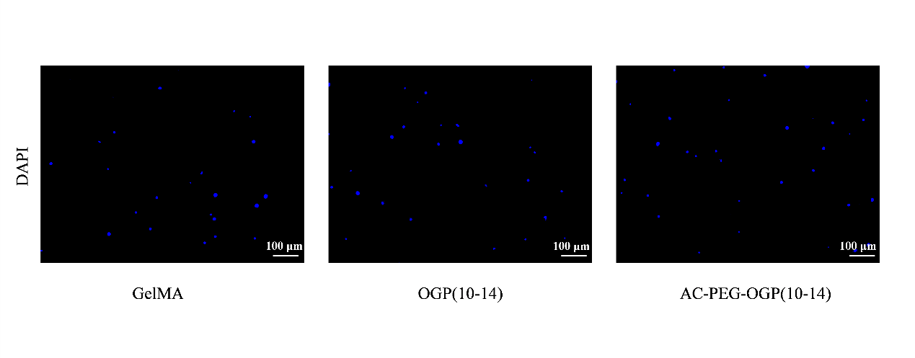
Figure S5. DAPI stained images of primary osteoblasts seeded on the composite material after 24 hours. n = 3. The scale bar represents 100 μm.

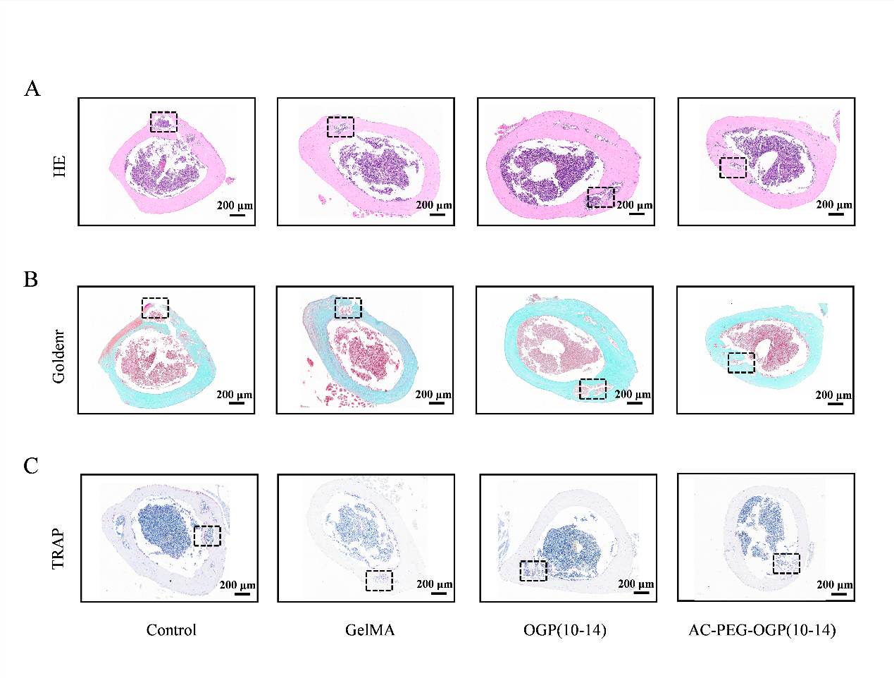
Figure S6. Evaluation of bone repair performance of different hydrogels. (A) HE stained images. (B) Goldner's trichrome stained images. (C) TRAP stained images. The black dashed-line box indicates the punch location. n = 3. The scale bar represents 200 μm.

