Supplementary Material

Detection of potential Mycoplasma contamination in cell lines using a PCR assay
To confirm the integrity and quality of the cell cultures, we performed mycoplasma contamination testing using the Mycoplasma PCR Detection Kit (GE Healthcare, Oberösterreich, Austria; cat. no. Q050-020) according to the manufacturer’s instructions. This analysis showed that the cells were not contaminated with Mycoplasma.
Fig. S1 PCR assay for the detection of potential Mycoplasma contamination in cell lines. A 700 bp internal control band confirms successful amplification in all samples. An additional band would indicate Mycoplasma contamination at approximately 500–520 bp. No such band was detected in any of the tested cell lines (L929, HUVEC, RAW 264.7, and HASMC), confirming the absence of mycoplasma contamination. Electrophoresis was performed on a 2% agarose gel.
Short Tandem Repeat (STR) profiling for HUVEC and HASMC cell lines
Short Tandem Repeat (STR) profiling was performed for the HUVEC and HASMC cell lines using the GeneMapper™ ID-X v1.6 system and a standard panel of human STR loci, including Amelogenin for gender determination. The analysis was conducted at the Malopolska Centre of Biotechnology, Jagiellonian University, Kraków, Poland. The resulting STR profiles were compared against reference profiles from public cell line databases and supplier documentation. Both HUVEC and HASMC exhibited unique and consistent STR patterns across all analysed loci, with no evidence of cross-contamination or mixed populations. The AMEL marker confirmed the expected sex origin (X for both lines), and all other loci showed stable allele distributions consistent with authentic and non-contaminated cell lines.
The complete STR profiles are presented in Table S1, along with additional documentation provided by the Malopolska Centre of Biotechnology. These supplementary materials include electropherograms for both HUVEC and HASMC cell lines, as well as a detailed allele table. These data confirm the identity and authenticity of the HUVEC and HASMC cell lines used in this study.
Table S1. STR profiles of the HUVEC and HASMC cell lines. STR profiling was conducted using the GeneMapper™ ID-X v1.6 system with a standard human identification panel to confirm the identity of the HUVEC and HASMC cell lines. The table lists the alleles detected at each STR locus. The profiles are consistent with authentic, uncontaminated human cell lines, with no indication of cross-contamination or genetic instability.
Locus | HUVEC | HASMC
AMEL | X | X
D3S1358 | 15, 12 | 17, 18.3
D1S1656 | 14, 17 | 14
D2S441 | 11 | 17.3
D10S1248 | 16.3 | 11
D13S317 | 14, 13 | 13, 12
Penta E | 11, 5, 7 | 5
D16S539 | 19 | 10
D18S51 | 11, 12 | 22
D2S1338 | 13, 18 | 9, 16
CSF1PO | 18 | 21
Penta D | 10, 9 | 7, 10
TH01 | 9.3 | 8
vWA | 31.2 | 18
D21S11 | 9 | 30
D7S820 | 8, 15 | 10
D5S818 | 18, 28 | 11
TPOX | 8, 13 | 6, 11
D8S1179 | 8, 11 | 14, 13
D12S391 | 19 | 13, 18
D19S433 | 14 | 22
SE33 | 11 | 12, 17
D22S1045 | 18 | 20, 11
DYS391 | 29.2 | 21
FGA | 11 | 24
DYS576 | 20 | —
DYS570 | 26 | —

Morphological and Growth Characteristics of L929 and RAW 264.7 Cell Lines
To confirm the authenticity of the mouse cell line L929 and RAW 264.7, we monitored and documented its morphology and growth over a 72-hour period following seeding. Observations were conducted at 24, 48, and 72 hours under standard culture conditions using inverted phase-contrast microscopy. Representative images were captured at both 100× and 200× magnifications.
At 24 hours post-seeding, L929 cells displayed a characteristic spindle-shaped morphology with elongated cytoplasmic extensions and were loosely distributed across the surface. By 48 hours, cell density had increased substantially, forming a semi-confluent monolayer while retaining their fibroblastic phenotype. At 72 hours, the cultures reached near-confluency, with cells forming a dense, contact-inhibited monolayer. These morphological features and the observed growth dynamics are consistent with the reference descriptions from the European Collection of Authenticated Cell Cultures (ECACC), including a typical doubling time of approximately 24 hours under optimal conditions (Fig. S2)
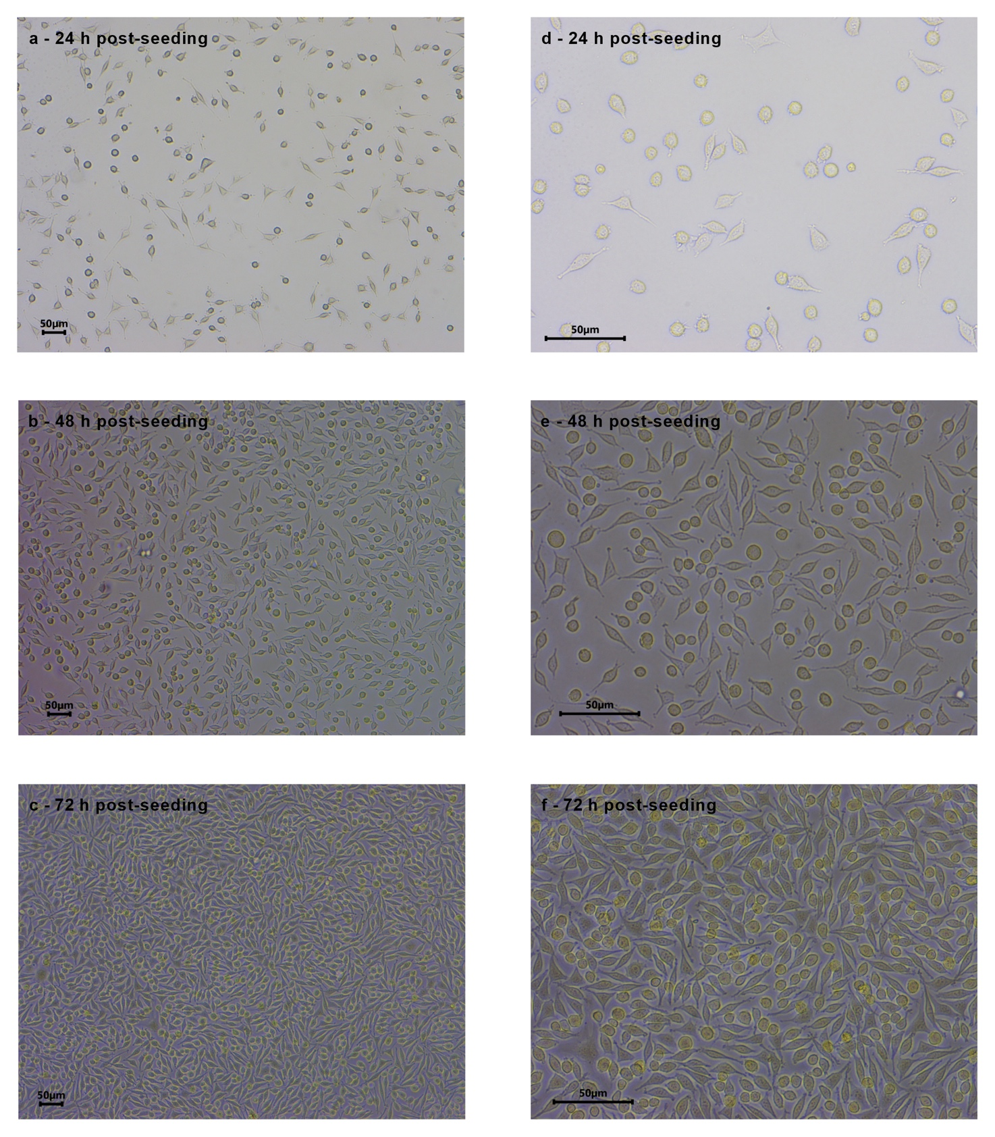
Fig S2. Representative images illustrate the morphology and confluency of L929 cells at 24-, 48-, and 72-hours after seeding, shown at 100× magnification (a-c) and 200× magnification (d-f).

At 24 hours, RAW 264.7 cells exhibited a predominantly rounded or oval morphology, were weakly adherent, and distributed individually or in small clusters. After 48 hours, enhanced adherence was evident, with cells beginning to spread and forming larger aggregates characterized by visible pseudopodia. By 72 hours, the cells displayed heterogeneous macrophage-like morphology, including spread amoeboid shapes, membrane ruffling, and increased surface coverage (Fig. S3)
Fig. S3. Representative micrographs display the morphological characteristics and confluency of RAW 264.7 cells at 24-, 48-, and 72-hours following seeding, at 100× (a–c) and 200× (d–f) magnification.
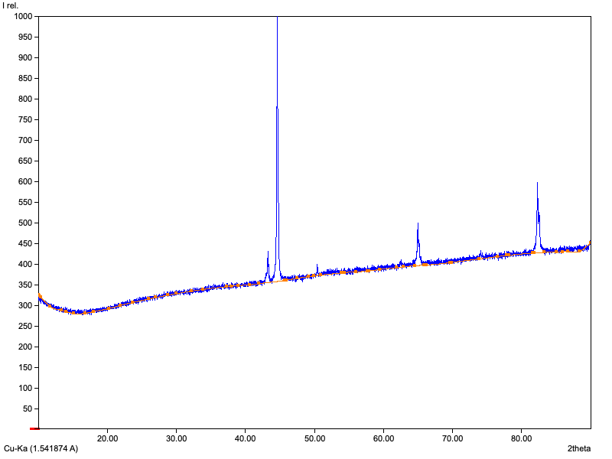
Fig. S4 XRD spectrum of FeCu sample
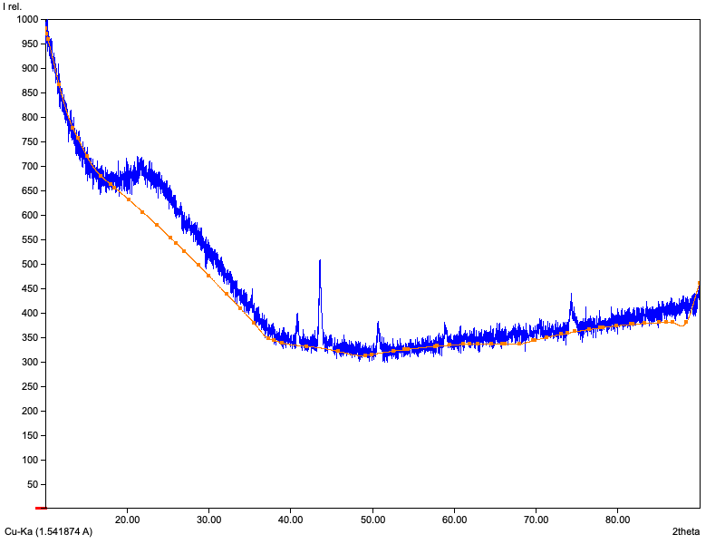
Fig. S5 XRD spectrum of FeMn sample

